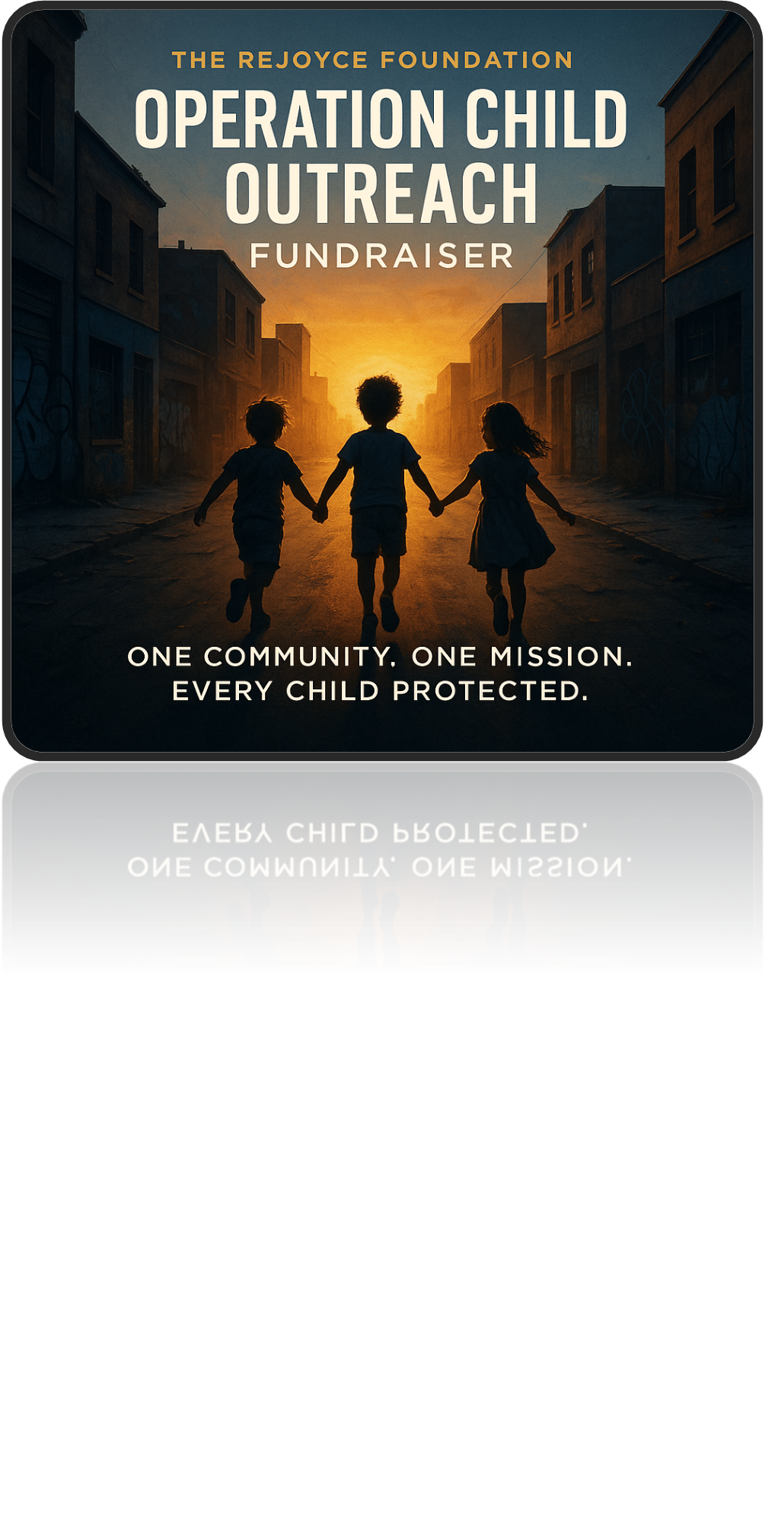

THE STARS OF OUR FUTURE IS THE CHILDREN

Organized by: The Rejoyce Foundation
Founder: Rickye Henderson
📍 Location: Hyder’s Food Park, 10800 FM 969, Austin, TX 78724
🗓️ Date: September 20th 2025 | 🕑 Time: 12pm- 8pm
🎯 Fundraising Goal: $50,000
________________________________________
One Community. One Mission. Every Child Protected.
Join us for an inspiring outdoor event filled with family fun, live music, guest speakers, food, and a powerful cause — protecting and empowering children in Austin’s most vulnerable communities.
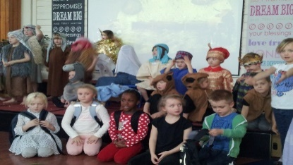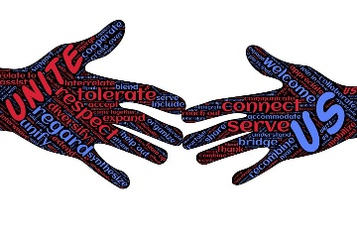

Free meals and festivities for all children now and forever — with transportation provided for qualified youth.
🎤 Live Music & Guest Speakers 🎮 Games, Activities & Prizes for all ages!
Line up TBA July 18th 2025
Our Mission
The Rejoyce Foundation proudly presents Operation Child Outreach, an urgent community response to children trapped in Austin’s and its surrounding areas most drug-infested, violent, gang-controlled, and poverty-stricken areas. A long-term goal to extend throughout the United States of America.
Our Skill-Set
Unlike any governmental agency or traditional child protection advocacy, The Rejoyce Foundation possesses an unparalleled and irreplicable skill set — one that no public agency, caseworker, or nonprofit can match without the leverage of criminal prosecution.
This expertise was not obtained through textbooks, government training, or policy manuals. It was forged through direct survival — in the trenches of violence, drugs, poverty, and street life. Founder Rickye Henderson, a former drug lord, gang leader, inner-city influencer, and Black male born and raised in Austin’s toughest neighborhoods [where incest, murder, crime, drugs, child abuse, disease and poverty is a norm,] built a reputation, respect, and a level of access to the city's most violent, abusive, addicted, and broken parents — the very individuals who would not dare speak to authorities unless they were facing arrest.
Because of his lived experience, Rickye Henderson holds a rare credibility and trust among populations that law enforcement, CPS workers, and advocacy organizations cannot even approach. In the absence of a crime, were traditional systems are powerless, The Rejoyce Foundation steps in — locating, identifying, registering, and protecting children before tragedy strikes.
This skill set is not just an advantage — it is the missing link in truly ending child abuse at its roots. Rickye Henderson does not hide this solution; he openly prays that others with similar backgrounds and capabilities will join the fight to protect our youth.
Through community re-engagement, free sports, real mentorship, street-level credibility, and a fearless commitment to saving lives, The Rejoyce Foundation redefines what is possible in child advocacy.
🔹 Locate. Identify. Register. Protect.
Every child deserves a safe, nurturing, and opportunity-filled future.

About Our Founder



Rickye Henderson is a 55-year Austin Texas native and dedicated UT FAN whose purpose was forged through a crucible of poverty, crime, disease, personal loss, and ultimately — redemption.
For decades, Rickye lived amidst the very dangers he now fights against: neighborhoods ravaged by drugs, violence, broken homes, and generational despair. His firsthand experiences as a former inner-city influencer, gang leader, and drug dealer granted him an intimate understanding of the deeply rooted struggles facing vulnerable children — a perspective that no textbook or government training could ever provide. Yet it was a personal tragedy that catalyzed his true transformation.

In 2014, Rickye's life changed forever when he cradled his beloved mother as she took her final breath from a massive heart attack. This devastating loss shattered him — but also marked the beginning of his spiritual awakening. In his profound grief, Rickye experienced the first stirrings of faith, a silent baptism of the soul that whispered a higher calling.
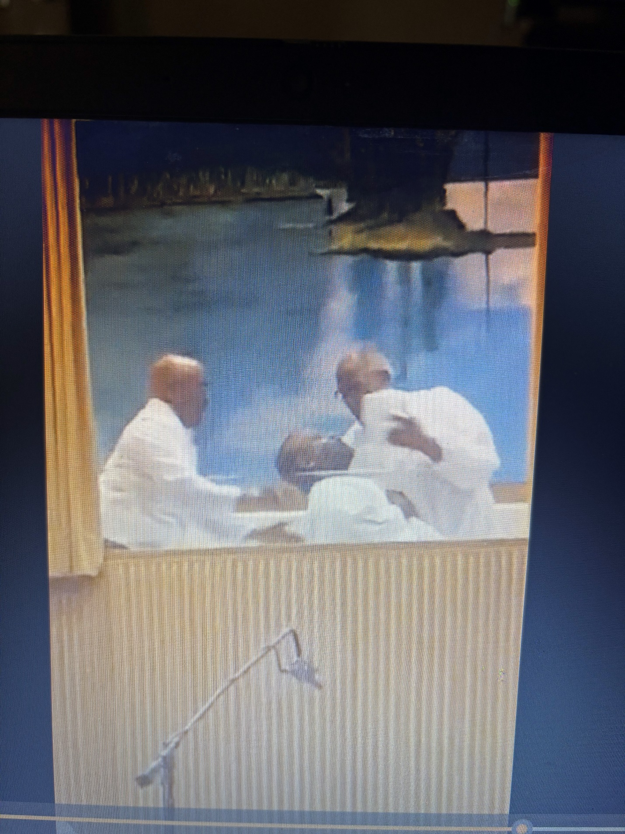
Arguably one of the most devoted and recognized men of GOD the late Reverend G. V. Clark, Baptizes Founder Rickye Henderson.
This spiritual rebirth culminated in a sacred moment: Rickye Henderson’s public baptism, captured forever in the image above — a symbolic surrender of his old life and a powerful affirmation of his renewed commitment to God and to service.
That commitment was seared into permanence nearly a decade later, when in 2023, Rickye's youngest son was brutally murdered. Confronted by unspeakable pain for a second time, Rickye did not collapse into bitterness or despair. Instead, he rose — fully renewed, anchored in unwavering faith, and charged with an unbreakable mission.
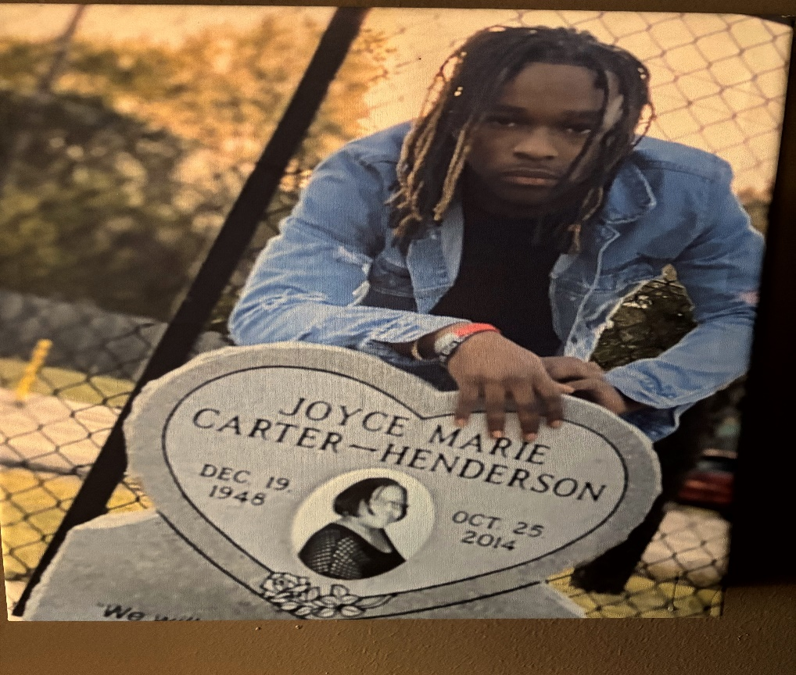
The death of his son reignited Rickye’s complete surrender to God's will and permanently anchored his life's work: to intervene where systems fail, to heal where wounds fester unseen, and to protect every child from the same violence that stole his own family.
Through these deeply personal baptisms of loss, faith, and rebirth, Rickye Henderson was transformed from a product of the streets into one of its fiercest protectors.
Today, as Founder of The Rejoyce Foundation, Rickye stands as a living testament that even the most broken beginnings can forge the most powerful agents of change.
This mission is not a career — it is his calling. This event is not just a fundraiser — it is the launch of a movement to protect and empower the most vulnerable among us.

🍴 Food & Refreshments
Included in most packages or available for purchase:
• Fried Fish, BBQ, Turkey Legs, Chicken, Hot Dogs, Nachos, Fries, Coleslaw, Hushpuppies
• Water, Gatorade, Soda, Beer, Wine
All proceeds from food sales go directly toward child protection and outreach operations.

Your Contribution Supports:
• 🚐 Mobile Outreach Van (rental, fuel, maintenance)
• 📋 Child Registration & Protection Systems (encrypted tablets, software, supplies)
• 🧹 Safety Gear & First Aid Supplies
• 📚 Educational & Healing Materials (books, trauma kits, child therapy guides)
• 🛡️ Volunteer Training & PPE
• 🏢 Administrative Infrastructure
- Computers, printers, office supplies, communication tools
- Filing systems, secure document storage, and clerical materials
- Space for operations, documentation, and volunteer coordination
• 🎉 Community Events & Child Empowerment Activities
No donation is wasted. Every dollar builds a safer, stronger system of child protection and advocacy.

🤝 Our Partners in Action
We proudly collaborate with:
• Local Businesses – donating backpacks, hygiene kits, print services
• Medical Teams – offering free screenings, immunizations, and education
• Law Enforcement & Fire – supporting security, mentoring, gang prevention
• Churches & Community Centers – offering space and emotional support
• Educators – leading trauma-informed sessions and tutoring
• Artists & Performers – spreading hope through music and creativity
• Tech Companies – providing secure, encrypted registration tools

Transparency & Accountability
We pledge full transparency.
Donors receive email updates, impact reports, and visual documentation of how every dollar is used to make real change.

Contribution Packages
Level | Package Includes
💛 Guardian of Hope — $25 | Event Ticket • Donor Wall • Digital Badge • Email Updates
Protector of Dreams — $50 | All Above + Certificate • Raffle Entry
🧁 Champion for Change — $100 | All Above + Wristband • Pin • Donor Spotlight
💙 Advocate for Action — $250 | All Above + VIP Seating • Event T-shirt • Awards Recognition
💜 Hero of Outreach — $500 | All Above + Appreciation Brunch • Impact Report
🔍 Defender of the Future — $1,000+ | All Above + VIP Recognition • Vehicle/Supply Sponsorship • Custom Award Plaque
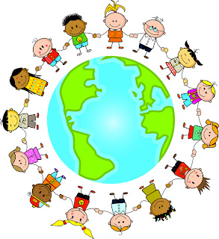
🎟️ Bonus Add-Ons:
• 🎫 Extra Raffle Tickets – $5 each
• 🧸 Sponsor a Child Registration Package – $40
• ⛽ Sponsor an Outreach Fuel Card – $75

VIP Sponsorship Opportunities
Level | Bronze ($1,500) | Silver ($2,500) | Gold ($5,000) | Platinum ($10,000+)
Website Recognition | ✅ | ✅ | ✅ | ✅
Event Materials Recognition | ✅ | ✅ | ✅ | ✅
VIP Tickets | 2 | 4 | 6 | 10
Dedicated Email Blast | — | ✅ | ✅ | ✅
Naming Opportunity | — | — | — | ✅
Full-Page Ad | — | — | ✅ | ✅
Logo on Outreach Van | — | — | ✅ | ✅
Impact Meetings Invitation | — | — | ✅ | ✅
Custom Award Plaque | — | — | — | ✅
Lifetime Founder’s Circle | — | — | — | ✅

Exclusive Founder Access
Included with every package and sponsorship level:
All contributors will receive an exclusive one-on-one session with Founder Rickye Henderson, either in person (at the event) or virtually (by appointment), where he will with no notes or prepared answers be able to clearly answer all your questions, concerns an or both:
- Personally share The Rejoyce Foundation's full, comprehensive solution for ending child abuse.
- Outline how individuals, agencies, and businesses can immediately implement steps to protect vulnerable children.
- Offer tailored guidance and opportunities for each partner to join this historic movement for real change.
- How this service can survive being free and why henderson does not care about sharing his solution to the world.

Rickye Henderson’s life experiences, unwavering dedication, and innovative action plan form the core strategy for Operation Child Outreach — and every donor, sponsor, and supporter will have direct access to this vision.
Together, we will create a safer future for every child.

🔺 Donate or Sponsor Today
• 🌐 Online: therejoycefoundation.com
• ✉️ Mail: 4909 Oldfort Hill Drive Austin, Texas 78721
• 📞 Phone: Rickye Henderson — (512) 788-2703
• 📧 Email: rickye1@sbcglobal.net

Slogan
"One Community. One Mission. Every Child Protected."

💬 Final Words
"When you invest in children, you invest in the future. Every child we save today becomes a generation we heal tomorrow."
🌟 Be the Spark. Be the Change. Join Operation Child Outreach.

🎉 Don’t Miss It!
Live music • Great food • Kids eat free • Community unity —
All happening at Hyder’s Food Park!
Let’s change lives — together.

Conclusion: A Future Rewritten
The Rejoyce Foundation is more than a rescue mission — it is the blueprint for a new future for Austin’s most vulnerable children. What we are building is not just a program, but a lasting sanctuary: a free, safe, violence-free, and drug-free haven where every child — no matter their background — can access sports leagues, mentorship, education, healing, and leadership development at no cost.
The ultimate foundation will represent hope without barriers:
• A place where neglected and at-risk children can belong, grow, and thrive.
• A facility that breaks cycles of poverty, violence, and trauma.
• A life-changing force that builds self-esteem, physical health, education, and opportunity — preparing youth to lead their communities, not just survive in them.
• A community-driven movement where mentorship, teamwork, discipline, and compassion lay the foundation for a safer, stronger future for every child.
Every donation, every partnership, and every moment of support contributes directly to this mission. Together, we will transform today's hardships into tomorrow’s triumphs — one child, one community, one future at a time.
🌟 The Rejoyce Foundation: Where Every Child’s Potential is Protected, Nurtured, and Realized.

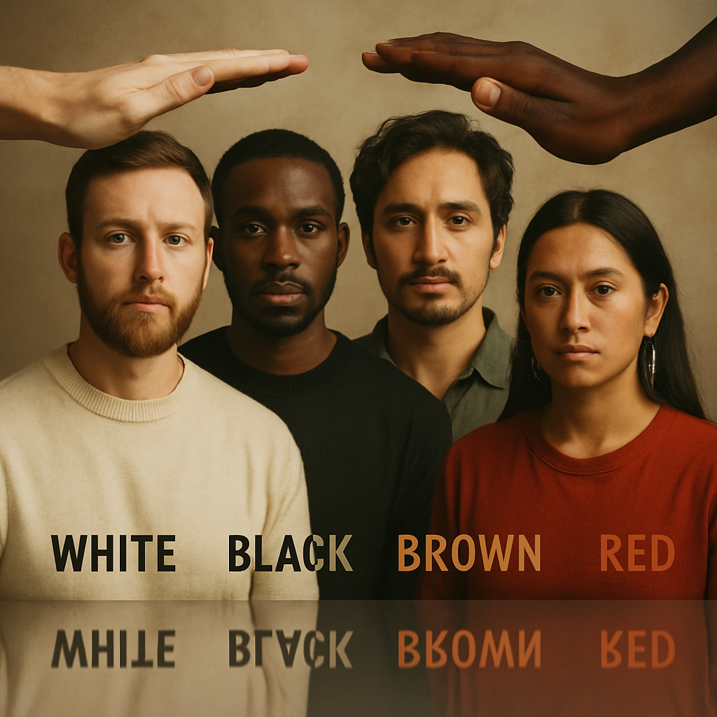
A letter to the viewer
The Rejoyce Foundation understands the immense dangers and obstacles inherent in the urgent humanitarian mission we have undertaken. We engage directly with environments scarred by abuse, trauma, addiction, violence, and generational despair.
Make no mistake: we are not vigilantes. We operate in strict and unwavering compliance with the laws of Texas and the Constitution of the United States.
This is a solemn word of caution — especially to those considering duplicating or mimicking our foundation’s approach:
No program built on promises, payments, legal deals, or incentives will ever succeed.
You cannot purchase authenticity.
You cannot contract credibility.
You cannot manufacture trust through negotiation.
You cannot broker transformation with a promise or a paycheck.
The work that The Rejoyce Foundation undertakes — penetrating the darkest corridors of violence, addiction, poverty and abuse — cannot be accomplished through deals, bargains, or quid pro quo arrangements.
It cannot be done with incentives.
It cannot be done through contracts.
And it certainly cannot be done by those who have never walked through the fire.
This work demands individuals whose lives bear the scars of survival — men and women who have not only witnessed chaos, but endured it. It requires a personal resurrection — a transformation born from pain, loss, faith, and relentless perseverance. It demands the presence of those who have lived the chaos, not merely studied it.
Founder Rickye Henderson’s unmatched access to the city’s most violent, abusive, and broken families did not come from any official title. It came from living among them. From understanding their world. From surviving the same fires that now fuel his compassion.
Let us be clear:
The solution offered by The Rejoyce Foundation is not for sale.
It cannot be borrowed.
It cannot be licensed.
It cannot be replicated through good intentions alone.
It must be lived, earned, and embodied.
A sincere and personal conviction, rooted in lived experience, is the only currency these communities recognize and respect.
This is why The Rejoyce Foundation stands apart.
This is why every supporter, partner, and donor joins not a business model — but a movement.
A movement of sacrifice, service, and salvation.
If you are driven by a genuine, unwavering desire to save lives — not for personal gain, but because you can bear the weight of the streets and offer the light of hope — then you are welcome among us.
But if you seek to purchase influence, manufacture credibility, or shortcut sacrifice, this path is not yours to walk.
Because in the battle for our children’s lives:
Only the genuine survive.
And only the genuine can heal.

A Foundation Forged in Redemption and Purpose
Most donors, contributors, partners, and potential allies hesitate to support The Rejoyce Foundation because of the unconventional qualifications required to truly save abused children. Our frontline advocates are often ex-cons, reformed gang leaders, former drug addicts — individuals society has long rejected. But it is precisely their lived experience that makes them the only ones equipped to break through where conventional systems fail.
In a nation that claims to believe in second chances, we ask:
Who better to reach abused and neglected children than those who have lived that same pain — and emerged with unmatched empathy, clarity, and strength?
I was once asked if prison had rehabilitated me.
My answer was simple: No — because I was never broken.
I’ve always known right from wrong.
In 1991, after seeing the pain my incarceration caused my mother, I made a solemn vow: I would never return to prison. Over thirty years later — even after holding my mother in my arms as she passed — I have kept that promise.
I stand today not as a statistic, but as living proof that transformation is not only possible —
It is powerful.
The Rejoyce Foundation is not built on promises or theory.
It is built on truth, transformation, and moral integrity.
It is forged through adversity and driven by a mission far greater than public approval.
We do not exist in spite of our pasts —
We exist because of them.
And the strength to rise from such a past?
It cannot be given. It must be earned.
And it must be lived.

The Rejoyce Foundation
"One Community. One Mission. Every Child Protected."

